About the UVA Health:
•UVA Health includes a hospital, level I trauma center, nationally recognized cancer and heart centers and primary and specialty clinics throughout Central Virginia.
•We rank among the nation’s top hospitals because of our doctors, nurses and caregivers who make every effort to push the envelope of healthcare.
•Our staff has been recognized for excellence by publications like U.S. News & World Report, Best Doctors in America, America's Top Doctors and more.

UVA Health includes:
•The UVA Medical Center includes the hospital, trauma center and primary and specialty care locations throughout Central Virginia.
•The UVA School of Medicine consistently attracts the nation's brightest students and most distinguished faculty members. The School of Medicine's 23 research centers continually make discoveries resulting in new and better therapies, especially in the areas of cancer, heart disease, and vaccine development.
•The UVA School of Nursing has earned a national reputation for excellence in education, research and practice. Ranked among the nation's top 25 public nursing schools, UVA offers undergraduate, master's level and doctoral nursing programs.
•The Claude Moore Health Sciences Library is a state-of-the-art library with a staff of professionals available to help healthcare specialists and patients find the latest health news and information.
•The UVA Physicians Group (formerly Health Services Foundation) is the physician group practice that manages billing for UVA physicians.
•The Transitional Care Hospital specializes in treating individuals with serious medical conditions that require a longer length of stay.

Mission
To provide excellence, innovation and superlative quality in the care of patients, the training of health professionals, and the creation and sharing of health knowledge within a culture that promotes equity, diversity and inclusiveness.

Values
This institution exists to serve others and does so through the expression of our core values:
Accountability: Acknowledging and assuming responsibility for where we have succeeded and failed in terms of our actions, decisions, policies and results
Stewardship: Responsibly and carefully managing our resources and commitment to continual improvement and learning while acknowledging shortcomings or problems in our quest.
Professionalism: Approaching all that we do, in a collaborative way, to deliver excellent care through the lens of helpfulness, positivity, kindness and competency
Integrity: Being honest, open and fair through our behaviors, attitude and treatment of others
Respect: Being mindful of building a diverse and inclusive environment while showing compassion for everyone through our caring and intentional ways
Excellence: Conducting ourselves in a manner that surpasses ordinary standards through our preparation, collaboration and proactivity in all that we do

Goals
•To become the safest place to receive care
•To be the healthiest work environment
•To provide exceptional clinical care
•To generate biomedical discovery that betters the human condition
•To train heath care providers of the future to work in multi-disciplinary teams
•To ensure value-driven and efficient stewardship of resources

A Brief History of the UVA Medical Center
Thomas Jefferson founded UVA's medical education and patient care program in 1825, but no hospital existed until many years later.
A dispensary was constructed in 1895. It served as a surgery center until 1901 and a place for outpatient care until 1916. Patients were taken across the street to a rooming house to recuperate from surgery. For a time, university doctors practiced at a six-bed, public, inpatient facility in a remodeled home.
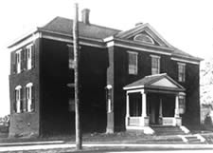
The Dispensary, 1892. This building stood on University Avenue near the present George Rogers Clark Memorial. Razed in 1916, the steps at the sidewalk survive. Photo: Historical Collections, CMHSL, UVa.
In the spring of 1901, UVA dedicated its first hospital: a 25-bed building with three operating rooms. By 1916, there had been three new additions to the hospital, bringing the total beds to 200. By 1941, rising patient volume had required another four additions to the hospital and brought inpatient capacity to 485.
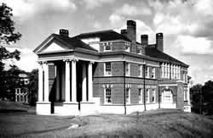
The University of Virginia Hospital, 1901, Paul J. Pelz, architect. Photo: Special Collections, University of Virginia (UVa) Library.
In 1960, the cluster of old buildings and additions saw its final expansion with the completion of a modern, eight-story, 400-bed structure that planners called the multistory hospital and the public dubbed the "new hospital." The new facility was air-conditioned, spacious and was equipped with the best technology available at the time. This facility served the area for almost 30 years.
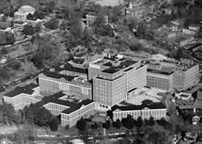
Aerial view of the Hospital, 1960. Photo: Historical Collections, CMHSL, UVa.
On March 20, 1989, a new University Hospital was opened. More than 140 patients were transported from the old building to the new building through a 700-foot link. The total project, including the 642-space parking garage and a heater/chiller plant, is the largest capital project in the state's history aside from highway construction. It had a budget of $230 million, including $24 million from the State.
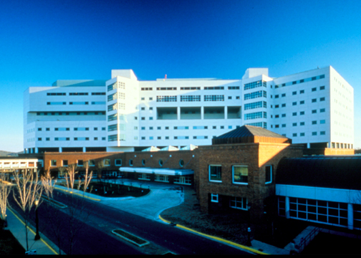

Changes at the UVA Medical Center
The UVA Health System strives to continually expand in all of our missions − patient care, education and research. This currently includes a 612 bed hospital, level I trauma center, nationally recognized cancer and heart centers and primary and specialty clinics throughout Central Virginia. We rank among the nation’s top hospitals because of our doctors, nurses and caregivers who make every effort to push the envelope of healthcare. Our staff has been recognized for excellence by publications like U.S. News & World Report, Best Doctors in America, America's Top Doctors and more.

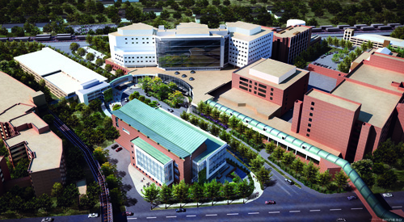
An aerial view of the buildings constructed south of Jefferson Park Avenue. Courtesy of Marketing Communications.
Access is everything — and we are constantly improving access to our wonderful facilities, advanced technologies, and expert physicians. A new, climate-controlled stair and elevator tower in the Lee Street Garage, along with other connective elements, make it more convenient for patients to travel to their appointments. Other projects, such as the lobby renovation, the elliptical plaza and the roundabout have made access easier for our patients and their families. A roof mounted helipad was added in 2012. This provides a faster, more direct route for the take-off and landing of Pegasus Air, the air critical care transport service operated by the University of Virginia Health System.

The Battle Building at the University of Virginia Children’s Hospital is a pediatric outpatient healthcare facility like no other in our region. Named for long-time UVA Children's Hospital benefactors Barry and Bill Battle, the building officially opened in June 2014. This seven story, 200,000-square-foot facility houses pediatric primary care, pediatric sub specialty clinics, a maternal and fetal medicine clinic, pediatric outpatient rehab services, the teen and young adult health center, outpatient surgery, a clinical trials suite, and clinical research office all in one location with immediate proximity to the UVA medical center. | 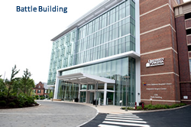
Opened in 2011, the five-story, 150,000-square-foot Emily Couric Clinical Cancer Center provides state-of-the-art therapies and comprehensive cancer care to patients and their families − all under one roof. In 2012, the new Stem Cell Transplantation Unit opened and is having a significant impact on advancing the clinical, educational, and basic science programs in the Division of Hematology-Oncology. | 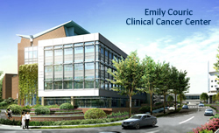
The opening of the new North Unit Expansion of the University Hospital in 2012 added 72 ICU-capable private patient rooms and dedicated education space. The UVA Health System uses EpicCare, an electronic medical record (EMR) in use at more than 50 U.S. academic medical centers. A team representing all clinical areas selected this program for its usability and comprehensive documentation of a patient’s medical history and treatment. | 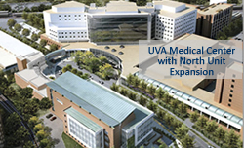
Opened in 2010, the 85,000-square-foot Claude Moore Medical Education Building serves as the central portal to the UVA School of Medicine and provides novel technologies and flexible teaching spaces to support innovative medical instruction. The facility includes specialized multimedia classrooms and Learning Studio, video-equipped exam rooms for analyzing student-patient interactions, and a Medical Simulation Training Center for honing skills. | 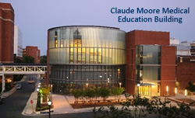
NIH support for medical research at UVA has grown significantly, and we are keeping pace with quality laboratory space. The 150,000 square-foot MR5 Biomedical Engineering and Medical Science Building and the 102,000 square-foot MR6 Carter-Harrison Research Building house laboratories for more than 700 researchers and technicians in biomedical engineering, pathology, cardiovascular sciences, cancer, immunology, allergies and infectious diseases. | 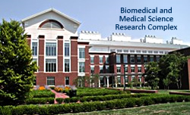
In October 2019, UVA opened its newly renovated and expanded Emergency Department. The ER is now three times larger than the previous space.  The new space has: 45,000 square feet, 70 beds, up from 45, with another 10 opening later  It also features: All private rooms, dedicated space for mental health services, separate space for pediatric and adult patients, TVs, seating, tables and charging stations in the waiting room  We’re also renovating the current emergency room space to create a clinical decision-making unit, opening in fall 2020. This will assess whether patients should be admitted, observed or discharged. | 

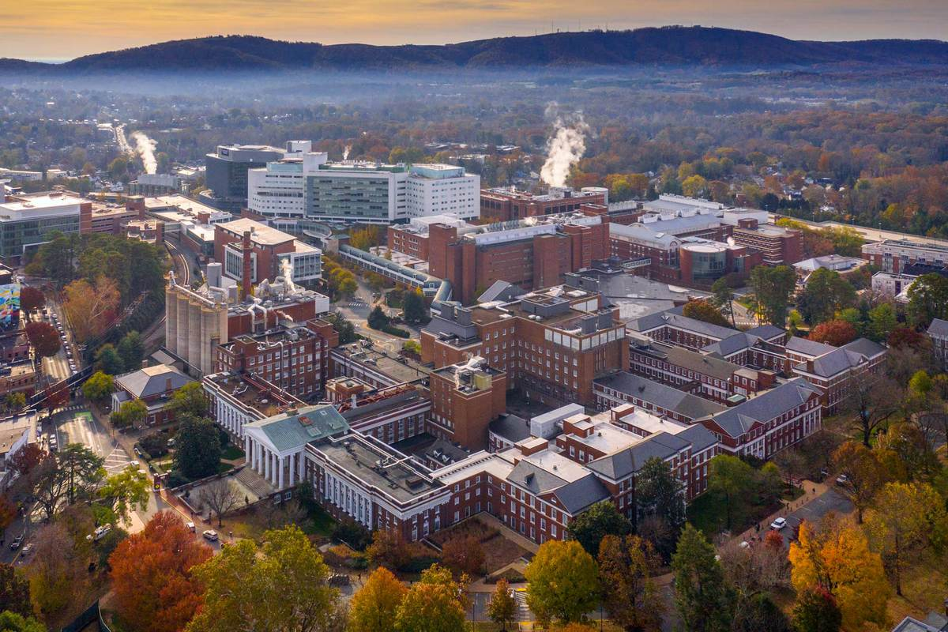

History: The School of Medicine
The School of Medicine, the tenth medical school to be established in the United States, was authorized in 1819. The school was established as one of the University's original eight in 1824, and opened in March 1825. The first degree offered at the University was that of the Doctor of Medicine in 1828.The original faculty consisted of a single professor, Dr. Robley Dunglison, whom Jefferson recruited from London in 1824. Dunglison was the first full-time professor of medicine in the United States and a leader in medical education. Unlike most other medical schools of the time, the School of Medicine was an integral part of the University and its professors held full-time appointments. The first dean of the school was appointed in 1904 as "Dean of the Department of Medicine." It was not until 1952 that the title of the dean became "Dean of the School of Medicine."
Today the school flourishes with a dedicated faculty, an outstanding student body, a flexible and innovative curriculum, patient care of the highest quality, and biomedical research programs nationally recognized for their stature and productivity. To supplement their classroom work, medical students gain clinical experience at the University Medical Center and affiliated hospitals and private offices throughout Virginia.


